For better understanding of lesson 11, you are supposed to do the pre-reading and self-study. Please read each section carefully and accomplish the tasks. Print materials as you need for class use.

Lesson 11 Reading and Writing the Body (I)
The Methodology & the Results
Lesson Objectives:
- To learn the writing of the Methodology
- To learn the writing of the Results, focusing on data commentary
- To learn how to describe different charts.

I. Reading and Writing the Methodology
1. Methods and Material
Read the following passages on methods and material to answer the questions below.
- What makes Methodology writing important?
- How much detailed should the Methodology be? And in what order should it be written?
- How much writing on materials should there be in the Methodology?
4) What is the structure of Methodology used in your research field?

1.1 Method = How the research was accomplished
A description of methods used is
- key to evaluating the significance of the research accomplished. If faulty procedures are used, obviously the results are questionable. You want therefore to convince your readers that you have used a sound methodology;
- in case of a new method or an unusual application of an older method, the description and justification may be as important as or more important than the results obtained.
- A “rule” of the scientific method states that the results based on the method must be reproducible, thus the method used must be described in sufficient detail.
First, give the preconditions necessary for applying the method. Describe preparations, if any, for performing the method. For example, describe the criteria for selecting specimens or subjects and how you assigned them to either the experimental or control groups. You should also describe any preliminary investigations which lead you to select the method you eventually employed.
Describe next in the chronological order the procedure employed. Group similar steps of a procedure together. In case of a new procedure, describe it in greater detail than a well-known procedure in your field. Describe the procedure only in general terms and refer to the original work if it has been elaborated in a previous RP in a readily available publication. Since the Results will follow the procedure in the Methodology, both should be organized similarly to clearly show the relationship between them.

1.2 Material — What resources were used during the research
The material is often combined with methods, and thus it is necessary to state with each step of your procedure the material required. Materials are any physical or abstract items used in applying the method. The term “resource” may be preferred to “material”. For example, in conducting their research, some investigators may rely upon a group of people as their resource for information. Materials/resources can be equipment, natural or man-made substances, computer or mathematical models, questionnaires, artifacts, biological specimens, or human subjects. Well-known materials in your field need to be briefly identified only. Unique or unconventional resources must be described in detail.

2. Components of the Methodology Section
(Overview; Research aims, questions or hypotheses; Subjects(课题) and/or materials; Location; Procedure; Limitation; Data Analysis)
Ex.11-1 Below is the Methodology in a RP entitled Changes in the chemistry of groundwater in the chalk of the London Basin. Read it to see what each sentence is about. Be prepared to analyze the Methodology’s structure in class.
Methodology
1 The current investigation involved sampling and analyzing six sites to measure changes in groundwater chemistry.(Overview) 2 The sites were selected from the London Basin area, which is located in the south-east of England and has been frequently used to interpret groundwater evolution.(Location)
3 A total of 18 samples was collected and then analyzed for the isotopes mentioned earlier.(Materials) 4 Samples1–9 were collected in thoroughly-rinsed 25 ml brown glass bottles which were filled to the top and then sealed tightly to prevent contamination.(Procedure) 5 The filled bottles were shipped directly to two separate laboratories at Reading University, where they were analyzed using standard methods suitably miniaturized to handle small quantities of water. (Procedure)

6 Samples 10–18 were prepared in our laboratory using a revised version of the precipitation method established by the ISF Institute in Germany.( Procedure) 7 This method obtains a precipitate through the addition of BaCl₂.2H₂O; the resulting precipitate can be washed and stored easily.( Procedure)
8 The samples were subsequently shipped to ISF for analysis by accelerator mass spectrometry (AMS).(Procedure) 9 All tubing used was stainless steel, and although two samples were at risk of CFC contamination as a result of brief contact with plastic, variation among samples was negligible.(Limitations)

3. Rules on the use of verb tense and voices:
1) You may use the active voice, although this section requires more use of third person, passive constructions than others.
2) Remember to use the past tense because it is a report of what was done during the course of the study. For example, the methods should be written in the form of procedural recount such as “we tested independently derived cultures for resistance to trimethoprim” or “cells were transfected, irradiated, and assayed for DNA damage”.
When one action occurred before another, the past perfect tense can be used to indicate the earlier action, with the subsequent action in the simple past tense. The past perfect tense is formed by combining the word ‘had’ with the past participle (typically the ‘-ed’ or ‘-en’ form) of a verb. Examples combining the past and past perfect tenses include “the cells that had been irradiated [past perfect] were assayed [past] for DNA damage” and “patients who had elected [past perfect] to undergo surgery completed [past] questionnaires”. In rare cases in which one action occurred while another was ongoing, the past progressive is used (e.g., “while the cells were incubating [past progressive], the temperature was raised [past] 1°C per hour” or “while patients were preparing [past progressive] for surgery, nurses collected [past] baseline samples”). The past progressive is a combination of the verb ‘was’ or ‘were’ and the present participle (‘-ing’ form) of the verb.

3) When necessary, use present tenses and past tenses to distinguish between standard procedures and what you did yourself.
e.g. Samples for gas analysis were collected using the method described by Brown (1999), which uses a pneumatic air sampling pump.

II. Reading and Writing the Results
1. Read to Learn about Results Writing
Determine whether the following statements are true or false after you finish the recommended reading passages. Specify your reasons if you decide a statement is false.
1) The Results can be comparatively shorter than other sections of a research paper. ( T )
2) The goal of the Results is to simply present the results of the investigation. ( F ) (not the only goal, also analysis)
3) You should try to describe every piece of data in detail. ( F )
4) An Appendix is necessary if you have too many data to be covered. ( T )
5) Figures and tables are strongly recommended since they provide information in a better way. ( T )
6) There is no need to describe any negative results of your investigation. ( F )

1.1 Recommended reading: Results = Research findings
This part presents the outcome of your investigation. The Results section should be the shortest, especially if the Methodology and Discussion sections are well written. This section shows your contribution to human knowledge. However, your goal is more than to simply present the results of your investigation, and it is to be understandable for your reader.
If you have a great deal of data to present, do so in three stages.
- Give a general overview in one or two sentences. For example: “The results obtained indicate that the film temperature increases as the rolling velocity or slide-roll ratio increases.”
- Present representative data, not the whole mass of data obtained. This is particularly important if an experiment or set of experiments were repeated several times.
3) If it is necessary to provide more than the representative data, do so in an Appendix, not in the text of your paper. This would also be done for interesting data observed but which otherwise did not affect the outcome of your investigation.
If you have a great deal of data to present, do not hesitate to use figures and tables. We use the term figure to include charts, diagrams, drawings and photographs. Rely upon your text to describe your findings, pointing out the most significant findings presented in your figures and tables. The human mind is capable of grasping a great deal of complex information when presented in a graphic than when presented in text. “A picture is worth a thousand words.” While in your text you can point out data that is displayed in a table, do not repeat the data in both places. This redundancy only adds unnecessary bulk to your paper.
Findings can be described and commented upon in four different ways: statement of fact, behavior over a range, comparison and contrast, and cause and effect. The latter two need to be commented upon at length; the following are examples of the former two.
Statement of fact:
It was verified that the average error in fuel spray droplet size is less than 10%.
Behavior over a range:
The interface between the saturated and unsaturated regions existed, but did not continue to exist when the water content was increased. The temperature at which the maximum concentration of H-related donor occurs increases slightly with thermal neutron dose.
Describe any negative results of your investigation. That is, state what you expected to find during your investigation but did not. What an investigation did not uncover often is of as great importance as what was uncovered.

- Briefly, data commentary goes like:
- Comment on the subject of the data
- Make a general comment on the main trend
- Comment on some of the significant features
- If appropriate, compare/contrast various aspects of the data
- Conclude by generalizing what you see as the significance in the data performance. This should be based on evidence.

1.2 Recommended reading:
pp. 91-153 in
Glasman-Deal, H. (2010). Science Research Writing: For Non-Native Speakers of English. Unit 3 Writing about Results. Imperial College Press.
(The book is accessible on the Internet.)

2. Components of the Results
Ex. 11-2 The indispensable unit of the Results is data commentary. Read the following Results to see the function of each sentence and to detect data commentary in it. It helps you better understand how to write data commentary. Try to summarize the elements a data commentary contains. Be ready for discussion with your classmates.
A modeling approach to traffic management and CO exposure during peak hours  Results  - Data obtained in previous studies using a fixed on-site monitor indicated that travel by car resulted in lower CO exposure than travel on foot. 2. According to Figo et al. (1999), the median exposure of car passengers was 11% lower than for those walking. 3. In our study, modeled emission rates were obtained using the Traffic Model (TEM), a CO-exposure modeling framework developed by Ka. 4. Modeled results were compared with actual roadside CO concentrations measured hourly at a fixed monitor. 5. Figure 1 shows the results obtained using TEM.  6.As can be seen, during morning peak-time journeys the CO concentrations for car passengers were significantly lower than for pedestrians, which is consistent with results obtained in previous studies. 7. However, the modeled data were not consistent with these results for afternoon journeys.  8. Although the mean CO concentrations modeled by TEM for afternoon journeys on foot were in line with those of Figoet.al., a striking difference was noted when each of the three peak hours was considered singly (Fig. 2). 9. It can be observed that during the first hour (H1) of the peak period, journeys on foot resulted in a considerably lower level of CO exposure. 10. Although levels for journeys on foot generally exceeded those modeled for car journey during H2, during the last hour (H3) the levels for journeys on foot were again frequently far lower than for car journeys.  11. A quantitative analysis to determine modeling uncertainties was applied, based on the maximum deviation of the measured and calculated levels within the considered period. 12. Using this approach, the average uncertainty of the model prediction for this study slightly exceeds the 50% acceptability limit defined by Jiang. 13. Nevertheless, these results suggest that data obtained using TEM to stimulate CO exposures may provide more sensitive information for assessing the impact of traffic management strategies than traditional on site measurement. | Function of each sentence is to be given below.  1-2.:  Previous research  3-4.:  Methodology and Results  - :  - :  Present data results  - :  Another side of the figure  8.:  Specific results  9-10.:  Specific results  - :  Method used to analyze the results  - :  Limitation  - :  Application of the work

- Q&A on writing the Results:
pp. 113-122 in Glasman-Deal, H. (2010). Science Research Writing: For Non-Native Speakers of English. Unit 3 Writing about Results. Imperial College Press.
(The book is accessible on the Internet.)
In the above extracts, find answers to the following questions:
- Why not start by describing my results?
- Why should I re-state the original prediction or the findings of other research here?
- Do I need to compare my results with those of other researchers?
- Why do I have to use evaluative language - why not simply describe the results which are in the figure or table?
- Isn’t a word like “striking” considered too informal?
- Should I explain my results as well as present them?
- How do I know which results to describe in detail? Why not describe all of them in detail?
- Do I need to mention problem in the results? Won’t it make the reader doubt my result?
- How can I talk about problems in the results?

3． Writing the data commentary
3.1 voice & sentence
Many data commentary sections begin with a sentence containing these two elements: location elements and /or summary statements. In English the active voice is as appropriate as the passive voice. (However, in a number of languages it may not be natural to say that a graph or other inanimate object "reveals,""gives," or "suggests.")
- Active voice:
Location Summary
Table 5 shows the most common modes of computer infection for U.S. businesses.
Table 2 provides details of the fertilizer used.
Figure 4.2 gives the results of the second experiment.
- Passive voice:
Summary location
The most common modes of infection are shown in table 5.
Details of the fertilizer used are provided in table 2.
The results of the second experiment are given in figure 4.2.

3.2 Highlighting statements
Highlighting statements are generalizations that you can draw from the details of the data displayed. It takes good judgment to make a highlighting statement. It is an opportunity to show your intelligence. In particular, it is an opportunity to demonstrate:
·that you can spot trends or regularities in the data;
·that you can separate more important findings from less important ones;
·that you can make claims of appropriate strength.
So, do not
·simply repeat all the details in words;
·attempt to cover all the information;
·or claim more than is reasonable or defensible.
Highlighting statements are usually ordered from general to specific. In other words, major claims are followed by minor claims.

3.3 Tenses
Because the experiments described in the text were completed before the paper was written, the Results section of a manuscript is also largely written using the past tense (for example, “we detected no fluorescence in the control sample” or “all participants reported a significant reduction in pain”). In certain cases, however, the present tense is needed. As described above for the Introduction section, the present tense is appropriate when referring to the entire paper or to individual elements of the manuscript (e.g., figures, tables, sections, results, or data). Examples of statements for which the present tense is best include “our results demonstrate that magnesium is essential for enzymatic function”, “Figure 1 shows our fluorescence dat”, and “in this study, we report the discovery of a new species of frog”. Note that sometimes two tenses can be found within the same sentence: “because no enzymatic activity was detected [past tense] in the absence of magnesium, our results indicate [present tense] that magnesium is [present tense] absolutely required”. The present tense is appropriate for the last verb because the observation extends beyond the specific experiment referenced in the first part of the sentence; it is now considered a statement of fact based on the results.

3.4 High-frequency expressions in data commentary
Nouns | rise, increase, fall, drop, decrease, fluctuation, downward trend, peak, steep fall, spike, minimum/maximum, local minimum/maximum, linear increase, kink, spike, low point
Verb | rise, increase, fall, drop, decrease, stabilize, fluctuate, level off
Accompanying adjective/adverb | steady/steadily; sharp; dramatic/dramatically; rapid/rapidly; slow/slowly; significant/significantly; unexpectedly; noticeable/noticeably

3.5 Terms to refer to Location
Inviting your readers to look at an illustration, you have to be able to specify what type of display you refer to, especially when it is not a table.
Display Examples
Diagrams flow charts, electrical schematics, models (e.g. networks)
Illustrations photographs, drawings (e.g. an apparatus/experimental set-up)
Maps political, physical, geological maps depicting phenomena
(a middle ground bw
diagrams and pictures)
Montages hybrids (combined display, e.g. of a graph and a photograph)
Graphs line graphs, bar graphs, scatter plots, pie charts

Ex. 11-3 Work in groups to revise the draft data commentary on the figure below. Be prepared to share the re-written version with the class.
Survival Time in Water of Different Temperatures
When Wearing Different Types of Clothing
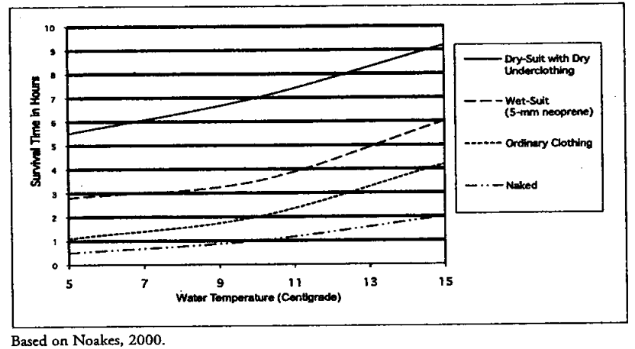
Draft:
The figure shows how long people can survive in water when they wear different kinds of clothing that have different levels of insulation. Clothing has an influence on how long a person can survive. The effect of clothing is greater at warmer temperatures. A person wearing no clothing in cold water survive only less than one hour.

III. Language Focus--Chart Description:
1. Useful ways to make a comparison:
x times as much/many n. as
x times the n. of n. as n.
more/less than x times the n. of n. (as n. )
more/less than x times –er than the n. of n.
more/less than x times –er than that of n.
more/less than % –er than that of n.

Ex 11-4: Identify which way is applied in the following sentences.
1) Women typically require twice the dosage of morphine as men to achieve the same degree of pain relief.
2) Each year, the average probability of dying from motor vehicle accidents in France was more than 12 times higher than the risk of drowning.
3) The median wage of a college graduate is now more than 70 percent higher than that of a high school graduate.
4) China produces four times as many engineers as the United States does.
5) Greece consumes more than double the amount of cheese as Denmark.

2. Read about different displays. Guarantee that you know which display best presents what type of information.
2.1 Diagrams
When the information has been collected, it is usually analyzed using various statistical techniques. It is then presented in tables, graphs or charts.
2.1.1 Tables
Country of Origin of Students on Foundation Course
 | Female | Male
China | 30 | 40
Japan | 2 | 8
India | 1 | 7
Pakistan | 1 | 4
Thailand | 3 | 1
Malaysia | 2 | 1
Tables:
- are efficient, enabling the researcher to present a large amount of data in a small space
- show exact numerical values
- present quantitative data - they need interpreting
- emphasize the discrete rather than the continuous.
They do NOT easily show:
- the number of students on the course
- the percentage of female students
- the percentage of female students from China
- relationships or trends.

2.1.2 Pie charts
Pie charts can be used to show the sizes of various parts of the results in relation to each other and in relation to the whole sample.
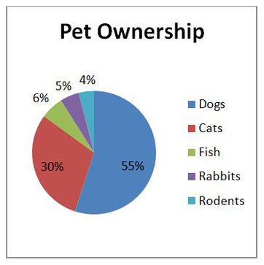
In the pie chart above:
- the circle represents the percentage of people who own various pets;
- each segment represents the number of people who own different pets;
- it clearly shows that the largest number of pet ownership is “dog ownership”, which means that most people represented in this chart own a dog as opposed to a cat, fish, or other animal;
- it also shows that rodents make up the smallest number of pets;
- it tells us that for pet owners, when choosing pets, rodents are at the bottom of their list; that’s not to say that rodents make the worst pets, but the data shows that pet owners prefer dogs first and foremost, followed by cats, then fish, then rabbits, then rodents.
2.1.3 Histograms
Histograms (or bar or column graphs) can also be used to describe results. However, they more clearly show the relationship of different parts of the sample to each other. They do not clearly show the parts in relation to the whole.
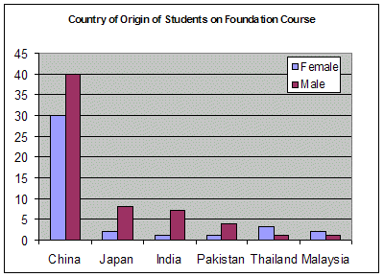
The histogram above clearly shows:
- the proportion of male to female students
- which country has the most students
- which country has the fewest women
- the number of students from India.
It does NOT easily show:
- the number of students on the course
- the percentage of female students
- the percentage of female students from China.

2.1.4 Line graphs
Line graphs are often used to show the results of studies, especially when they involve some kind of change over time. This usually involves two groups of measurements which are known as variables.
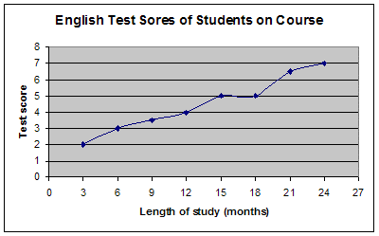
The graph above shows the differences in the English test score of the students on the course:
- The two variables are the length of time the students have studied English and the students' test scores.
- The length of study causes the change. (This is called the independent variable and the other - the test score - the dependent variable.)
- The length of study is on the horizontal (x) axis.
- The test score is on the vertical (y) axis.

The line graph shows well:
- trends & tendencies (- you can see that the test score generally increases as the length of study increases)
- that a typical student who has studied for 12 months has a score of 4 on the test
- that a typical student who has scored 6 on the test will have studied for 18 months.

In the graph below:
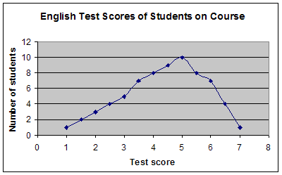
- The independent variable is now the test score.
- The dependent variable is the number of students who obtained a particular score.
- The highest score is 7 the lowest score is 1.
- The most common score is 5.
- 8 students achieved a score of 4.

Ex. 11-5 Discuss with your team to present the significance of the three charts below by applying what has been covered on data commentary. Be prepared to contribute your idea to the class on any of the three.

Chart 1
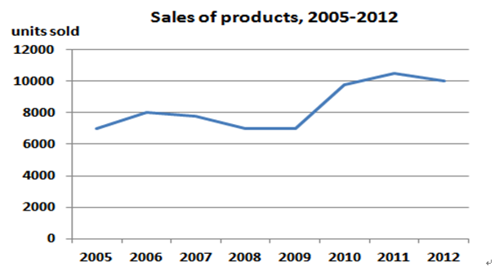

Chart 2
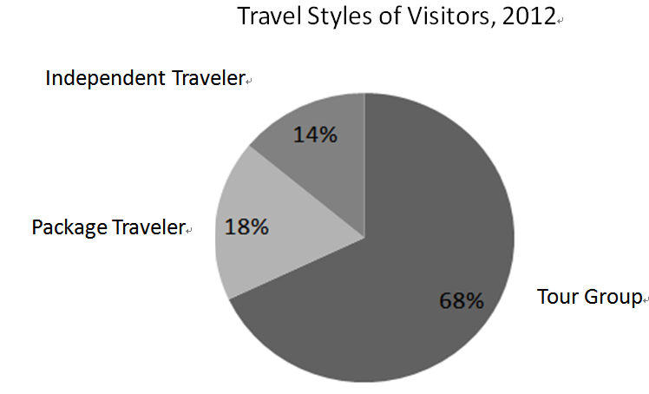
Chart 3
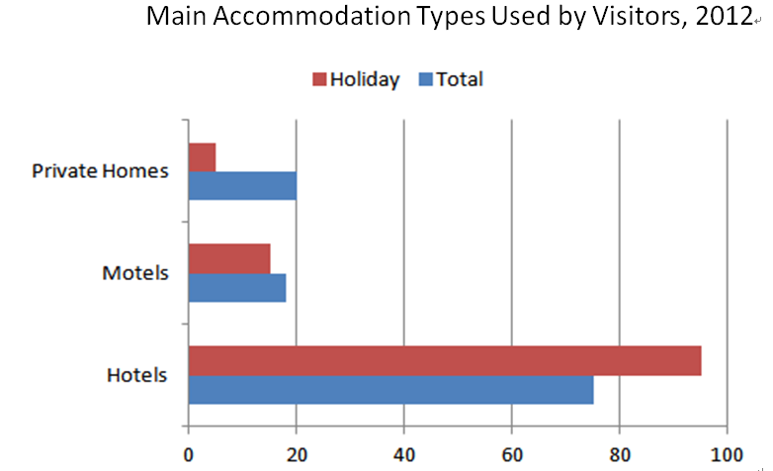

Ex. 11-6 The genre of reports is usually adopted in data commentary. Refer to types of reports, examine the displays below, and decide on the type of report that is best suited for describing the two bar charts. See if you agree with your class.
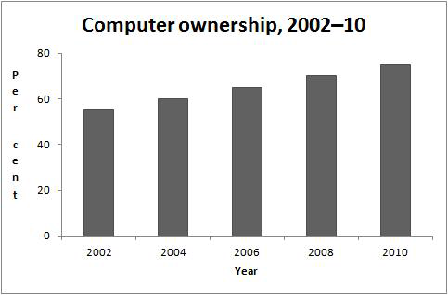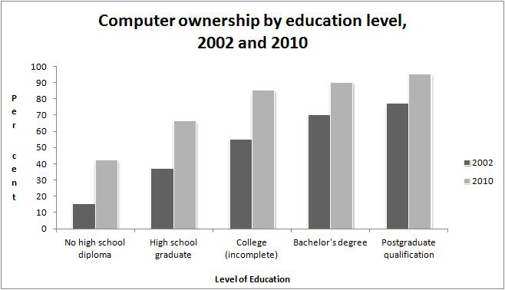

Homework
1. In some experiments, the data you are working with may not always be perfect. In other words, it could contain some anomalies, or there may be discrepancies between the actual findings and the expected ones. Additionally, there may be obvious limitations in the study for which the data was collected. If any of these problems or limitations exist, usually the best strategy is to show the difference and make a comment about them. Try to explain why these unexpected results or errors occurred.
Look at the following graph and the accompanying data commentary written by one of our students. We have, however, omitted certain words and phrases. Complete the passage by referring to language in the Results in the journal articles you chose. Bring your version of the data commentary to Week 13 class.
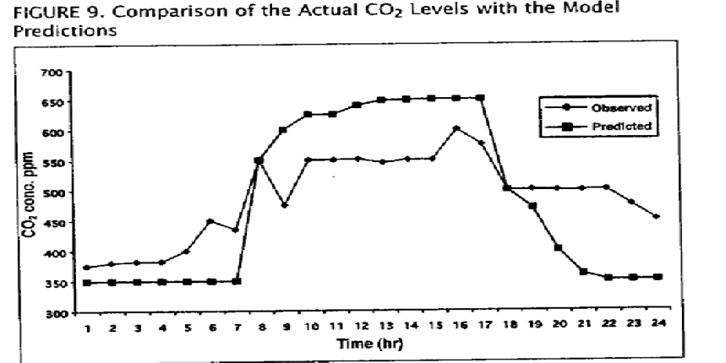
The observed and predicted CO2 levels for 24 hours in a commercial building ___1___ in figure A. The actual CO2 concentrations were ___2___ directly from sites in the building CO2 by the Trapping Method. The predicted concentrations were calculated by using one of the available indoor air quality models. In this case, the “fully stirred and conservative reactor with internal source model”___3____ since it was assumed that the air was completely replaced and mixed with fresh air every hour, and there was no degradation.
____4____ shows that the predicted CO2 concentrations increase sharply after 8 _{AM} and ___5___ steeply after 6 _{PM}. This is because the CO2 levels were____6____ to be dependent on the number of people in the building since people produce CO2 as a result of respiration. However, the model overestimates the CO2 levels during the occupancy periods ( 8 _{AM}to 5 _{PM}) and ___7____.The lower CO2 levels found in the occupancy period ___8____ several factors, such as the presence of plants, which generate oxygen, while using CO2. ___9____, the predicted levels are lower than the ___10___ during the vacancy period because the model assumed that nobody was in the building after 6 _{PM} and that the air was fully mixed. In fact, there might be overtime workers in the building after 6 _{PM}, or the ventilation rate ___11___ during the vacant period. Although the “fully stirred and conservative reactor with internal source model” tends to overestimate or underestimate ___12___ occupancy, overall, it performs well with a coefficient of 0.9 (r=0.9).

2. With discussion on Ex. 11-6 in class, continue to write a data commentary on the two bar charts. Please use the template below, and label each phase in the report and element in data commentary. Bring it to Week 13 class.
EAP Class Number: ______________
Name: ______________
Student ID: ______________
Type of Report adopted: _____________________

Phase 1: _____________

Phase 2: _____________

___________ (Element of data commentary)

___________ (Element of data commentary)

3. Read the handout of Lesson 12 and complete the related exercises

